**Luxury Square Abstract Wall Art**

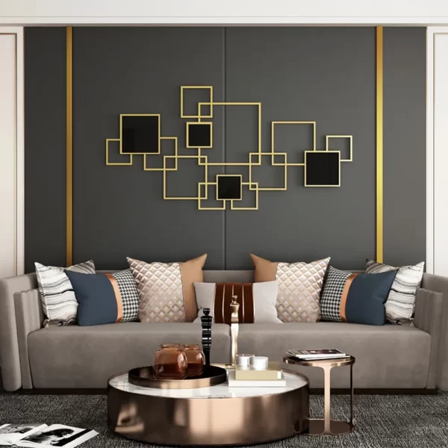Luxury square abstract wall art with black glass is a sophisticated statement piece that effortlessly enhances any modern or contemporary interior. Featuring sleek, clean lines and an artistic interplay of textures and colors, this art piece exudes elegance and refinement. The black glass element adds a glossy, reflective surface that contrasts beautifully with matte or metallic finishes, creating a striking visual depth. Perfect for living rooms, dining areas, or office spaces, it serves as both a decorative focal point and a conversation starter. This wall art embodies the essence of luxury, transforming any space into a gallery inspired haven.